Organisational Capacity Assessment (OCA) and Capacity Development Grants for LGBTQIA+ organisations
Application form

- Organisational Self-Assessment Questionnaire (Guidelines)
Please fill in the Excel document 2. OCA_Self-assessment questionnaire

Fill in the scores using the dropdown lists in columns C and D. Please make sure to fill in Columns C and D for all organisational development fields.

If some specific organisational development fields are a priority for your organisation (and receives a score equal or higher than 3 in the Priority Level column), please fill in the two areas next to it with the required information (Column E: explanation to the realities and challenges your organisation faces in that particular field; Column F: the activity(ies)).
Before submitting the proposal, please review and ensure that all sections are consistent.
We invite you to fill in the Self-assessment questionnaire before filling in the present application form as we believe the assessment might help you building a strong application.

II. General information about the applicant

Official name of the organisation  (if informal group, include the name used by the group) | English:  Original:
Registration number of the legal entity (if applicable)
Country and region of the organisation
Contact person (Full name and position)
Email
Phone number / Signal
How long has your organisation/initiative been active?
Indicate the number of members of your organisation/initiative: (full-time employees, part-time employees, volunteers)
Is your organisation / initiative part of a LGBTQIA+ oriented coalition?
Website and social media page(s) of the organisation (if applicable)
The geographical area in which the activities of your organisation / initiative are implemented
Please provide 2 professional references (e.g., donor representatives, partner organisations) whom your organisation or initiative have worked with, including their e-mail contacts.
Are you comfortable working in English? | ▢ Yes ▢ No
Summary of your provisional capacity development project (max 150 words):
Tentative budget of provisional capacity development project (EUR)

Please provide a brief description of your organisation (maximum 200 words).
You can include information about your mission, vision, target group(s), main activities to support the LGBTQIA+ community, the number of people involved in your organisation/initiative, community-led organisation, etc.
Please describe If and how your organisation operates outside capital cities and/or work with marginalised or underserved populations (including LBTQIA+ women).

Please describe the main challenges or risks your organisation is currently facing, and how have these affected your work or activities. What steps or mitigation plans has your organisation put in place to address these challenges? How effective have they been?
Has your organisation conducted any strategic planning sessions or needs assessments? If yes, how have the findings been integrated into your work? (If not, it is not an issue—this will not affect the evaluation of your application.)
(Max. 300words)

Needs of the organisation and provisional capacity development plan

Please describe the specific issue(s) and needs of your organisation you think the OCA and capacity development grant could address particularly.
The Self-Assessment Questionnaire, shared with this application form, should particularly help you prepare the answer to this question.
(Max. 300 words)

Provisional capacity development project

What activities do you think could be implemented in the framework of the capacity development grant to strengthen the capacities, resilience, and effectiveness of your organisation? Why are these needed and how will you measure the achievement of these goals?

Please answer in the following table. Note that the first row is purely indicative. Add as many rows as needed.

Note that the activities that will actually be financed by the capacity development grant will be determined following the OCA analysis and may be completely different from what you are considering today. However, knowing more about your vision of relevant capacity development activities for your organisation is very important in the selection process and lay the basis for the OCA assessment.
Activity | Need(s) related | Output | Period of implementation | Location | Means of verification
A1. Legal support | The organisation faces numerous legal crises, which hampers the efficient conduct of its activities. CSO has limited internal capacity to respond effectively to these crises. | 10 Board members and upper management receive 24 hours of legal, fiscal and crisis management consultations | August – October 2025  (2 months) | Online | Comprehensive Legal Analysis Report  Governance Structure Review  New management plan put in place

Please describe the key ways in which this project will strengthen your organization and explain the mechanisms (how/why) through which these changes will improve resilience and long-term sustainability (max. 200 words)

What risks or challenges do you anticipate in implementing the project (both OCA assessment and capacity development grant)? What measures will you take to mitigate them?
(Max. 300 words)

Please indicate below if you have received (in the past 2 years) or recently requested other funding to strengthen your organisation's capacities and resilience? If so, please provide details about the projects (donor, amount, activities, results).
Donor/Funding source | Amount | Short description of the support and impact

Tentative budget
Please fill in the Tentative Budget From template in Excel and copy paste a screenshot below.
Example:
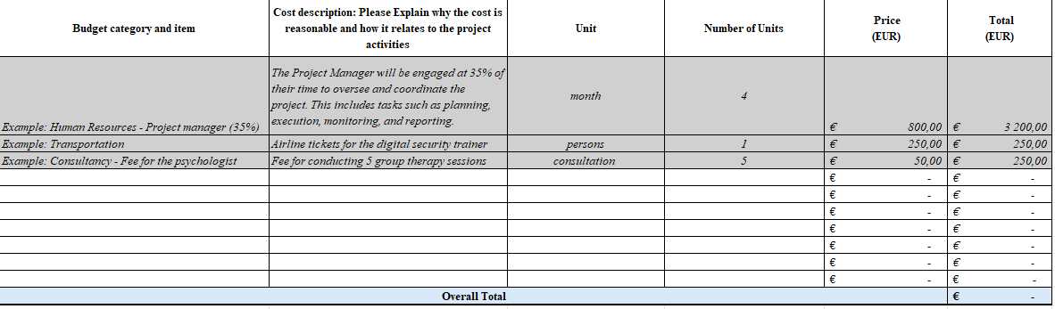

Submission of the application:
The application package includes mandatorily the following documents:
I. Application Form (.doc)
II. Organizational Self-Assessment Questionnaire (.xlsx)
III. Tentative Budget From (.xlsx)
Application From, Organizational Self-Assessment and Tentative Budget must be sent to the email address: ocasupportwb@media-csos.com Please state in the subject line “Application OCA for country name”. The applications should be submitted in Word (Application form) and Excel (Self-assessment questionnaire) documents.
The application form can be submitted in Bosnian, English, Macedonian, Montenegrin or Serbian. If the application is submitted in local language, please, provide an English version of your application in addition to the original one, Google translate is an acceptable method of translation.
Proposals must be submitted online by 1st Decembre, 17:00 CET. All applicants will receive a confirmation from the project team upon receipt of the email with a project proposal.
ERIM and ERA will be hosting an information session (in English) on November 14th, 2025 at 14:00 CET. To participate, please register here and submit your questions in advance.

Refer to the Call for Applications document for details on eligible activities under this support.

